Arraignment Day - December 6, 2013

Today I was scheduled to be arraigned. I showed up at about 8:59. I took a seat in the crowded courtroom. Upon being ushered to the center of the row and seated more closely to make room for everyone to sit – I was next to a young woman with beautifully braided hair. She was also there for “Arraignment”. This was her 2nd appearance for “Arraignment”, as the previous time a few months ago, the court was not prepared so they scheduled a new court date for her. This court process is called the “Dry Run”, it is especially annoying to the court attendee when they are in custody. Dry Runs are a form of punishment in some places. I advised her to plead “not guilty” and take her case to trial after hearing a bit about it and the sister/roommate involved.

I was called to the front of the court by what appeared to be some court clerk. The judge had not entered the courtroom yet. I have been to court many times ( My old journals kept count - I may be past 150 appearances by now) this seemed strange, but each court is different. Judge Carey Nelson keeps a box of shirts in his courtroom. Court attendees are forced to wear one of them if they show up to court in a shirt without a collar, as I did.

I was informed by this seemingly official woman who worked behind the bench with all the attorneys and court employees that my case has not been prepared, or for some other reason that she is unaware of my case has no case number. I was excused from court.  I said, "I am out on bond.  You are telling me to leave and not even going to give me a date to appear?".  I was told that they will mail me a court date. Upon request, she gave me this card that I interpret to be a “Get Out Of Jail Free Card”. It didn’t come easy, and I do deserve it, so thank you, and I’ll take it.

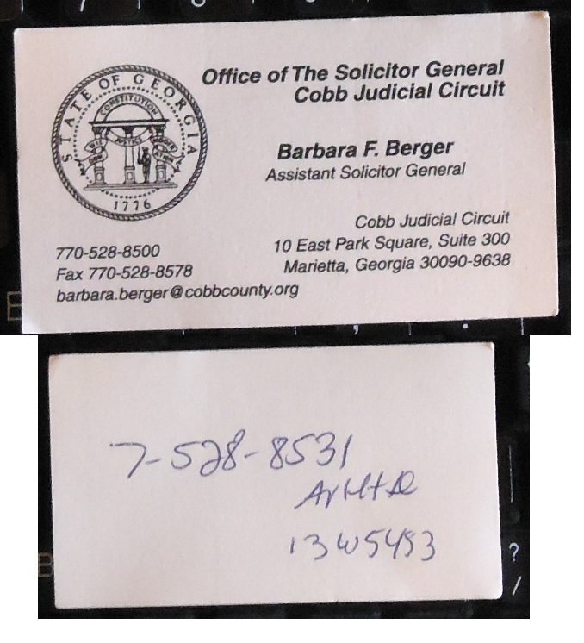

It looks like someone has been hacking the court database.  I did not do it,